

American International University-Bangladesh (AIUB)  
**Department of Computer Science  
Faculty of Science &Technology (FST)  
Fall 22 23**

**Poultry Farm Management System**

Software Requirement Engineering

Sec: **A**

Project submitted

By

*Sumaiya Afrin Jassi (19-40603-1)*

*MD. Fahim Attef (19-39963-1)*

*A.S.M Ashiqur Rahman Rumee (19-39970-1)*

**Checked By Industry Personnel**

Name:

Designation: Lead Product Manager

Company:

Sign:

Date:

**1. Problem Domain:**

**1.1 Background to the Problem**

A person with so much work load in his daily life who want to make a proper shopping plan but ultimately failed because of their daily busy life. Even though many people are not used to with daily grocery shopping. Also many people feel uneasy going into local bazar. So, this poultry farm management system is for all of them. This is a system for the people who can specially buy their poultry items through this system. Also this is time consuming. Those who are not used to with daily shopping this system will make their life more easier. People will not face any kind of problem using this system.

**1.2 Solution to the Problem**

Our topic is about poultry management system. We will like to discuss this in V shape model. The V-Model is a unique, linear development methodology used during a software development life cycle (SDLC). The V-Model focuses on a fairly typical waterfall method that follows strict, step-by-step stages. While initial stages are broad design stages, progress proceeds down through more and more granular stages, leading into implementation and coding, and finally back through all testing stages prior to completion of the project.

In this article we’ll examine just what the V-Model actually entails, and why it may (or may not) be suitable for certain types of projects or organizations.

The process of the V model is much like the traditional waterfall model, the V- Model specifies a series of linear stages that should occur across the life cycle, one at a time, until the project is complete. For this reason, V-Model is not considered an agile development method, and due to the sheer volume of stages and their integration, understanding the model in detail can be challenging for everyone on the team, let alone clients or users.

**2. Solution Description:**

**1.1 System Features**

* 1. Log in:
     1. The system shall record name
     2. The system shall record id
     3. The system shall record phone
     4. The system shall record address
  2. Breading:
     1. The system shall record chicken breeds
     2. The system shall record chicken age
     3. The system shall record total number of chickens
  3. Feeding:
     1. The system shall record seed category
     2. The system shall record feeding time
     3. The system shall record food quantity
     4. The system shall record food name
  4. Medicare:
     1. The system shall record vaccine date
     2. The system shall record oral medicine date
  5. Shade:
     1. The system shall record number of shades
     2. The system shall record number of hens in per shade
     3. The system shall record number of medicine & supplements
  6. Expense:
     1. The system shall record expense in seeds, medicine, supplements

**2.1 UML Diagrams:**

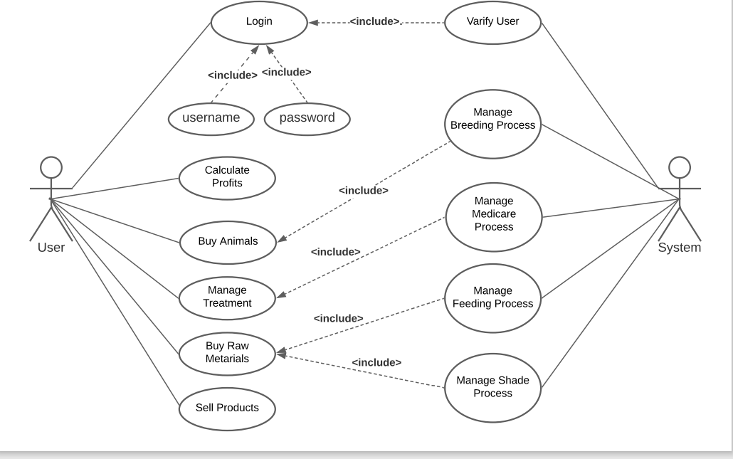

**FIG 1: USE CASE DIAGRAM**

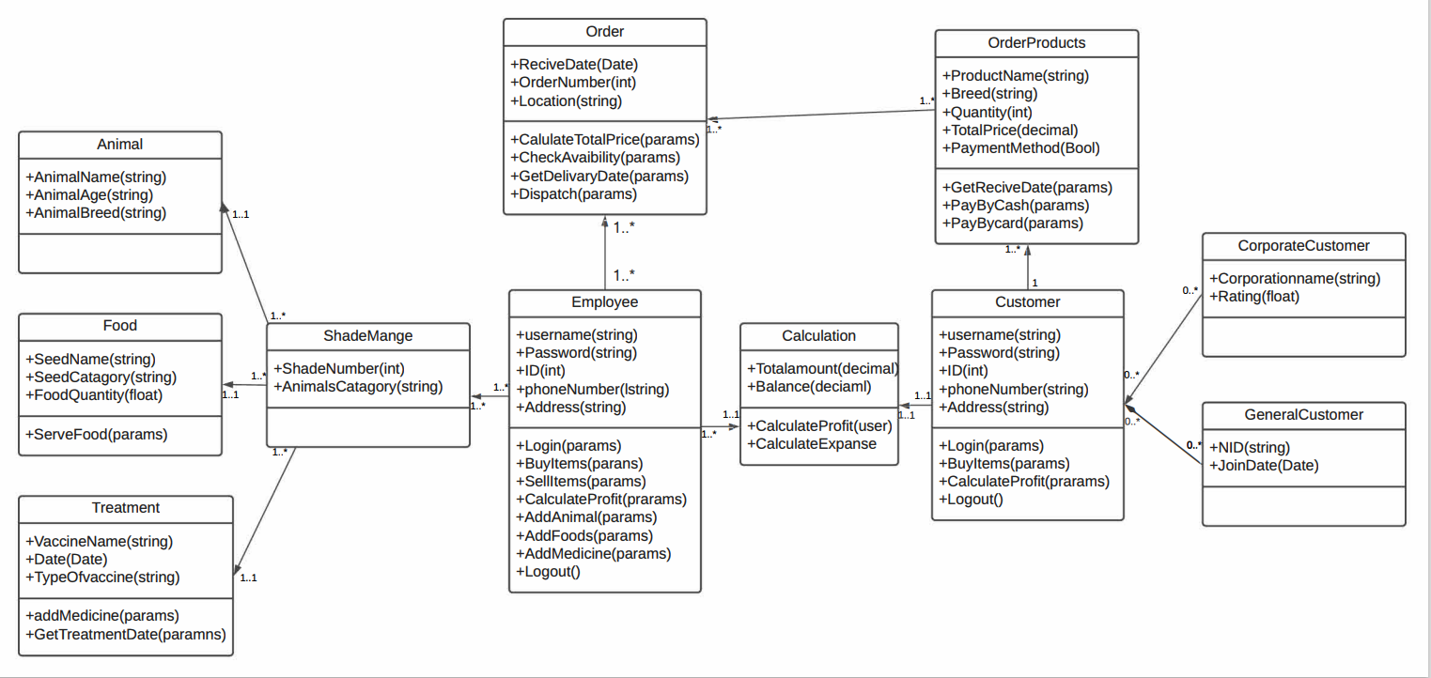

**FIG 2: CLASS DIAGRAM**

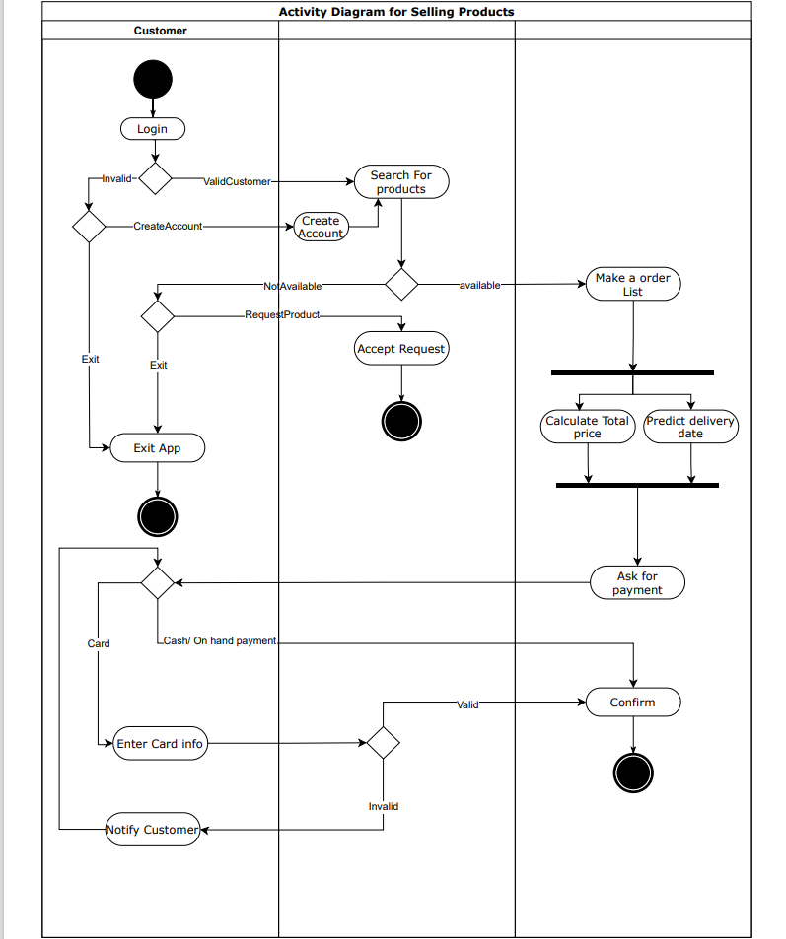

**FIG 3: ACTIVITY DIAGRAM**

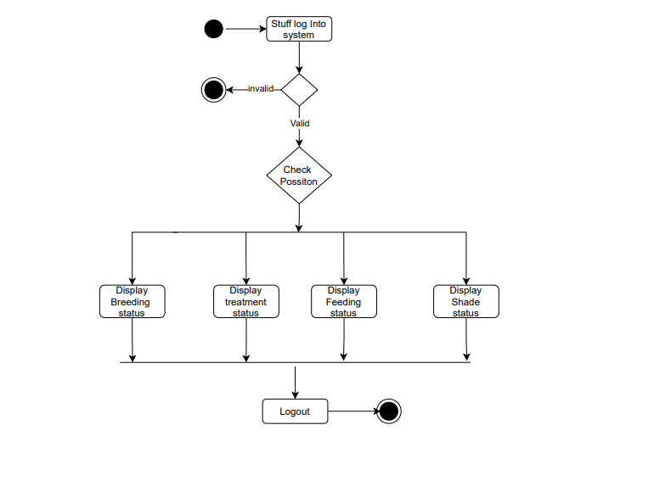

**FIG 4: FLOWCHART**

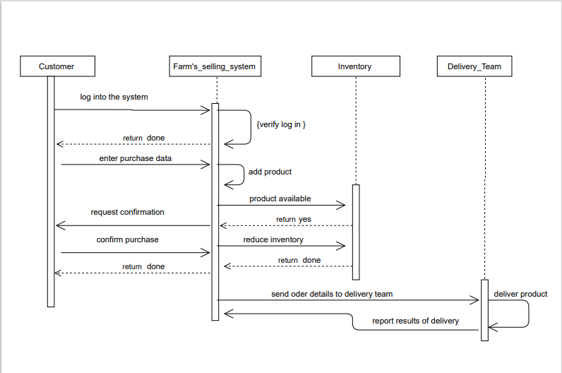

**FIG 5: SEQUENCE DIAGRAM**

**The responsibilities of the role in the software development:**

## Requirement’s analyst:

In this phase, the requirements of the proposed system are collected by analyzing the needs of the user(s).

## System Designer:

System engineers analyze and understand the business of the proposed system by studying the user requirements document. They figure out possibilities and techniques by which the user requirements can be implemented. If any of the requirements are not feasible, the user is informed of the issue. A resolution is found and the user requirement document is edited accordingly.

## Architecture Designer:

The baseline in selecting the architecture is that it should realize all which typically consists of the list of modules, brief functionality of each module, their interface relationships, dependencies, database tables, architecture diagrams, technology details etc.

## Module Designer:

The designed system is broken up in to smaller units or modules and each of them is explained so that the programmer can start coding directly. The low- level design document or program specifications will contain a detailed functional logic of the module, in pseudocode - database tables, with all elements, including their type and size - all interface details with complete API references- all dependency issues- error message listings- complete input and output for a module.

**4. Development Plan with Project Schedule:**

**Development Plan:**

❖ Identify and meet with stakeholders

❖ Set and prioritize goals

❖ Define deliverables

❖ Create the project schedule

❖ Create a budget

❖ Add milestones

❖ Identify issues and complete a risk assessment

❖ Present the project plan to stakeholders

**Project schedule:**

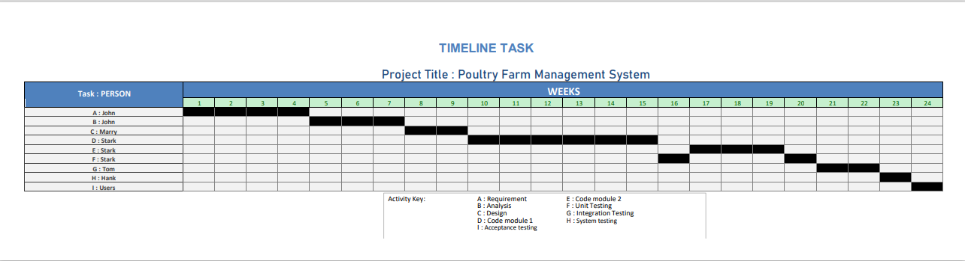

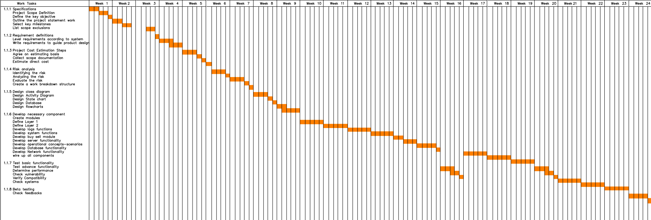

|  |  |  |  |  |
| --- | --- | --- | --- | --- |
| **Serial NO** | **Risks** | **Category** | **Probability** | **Impact** |
| 01 | Schedule Risk | PS | 40% | 1 |
| 02 | Budget Risk | PS | 55% | 2 |
| 03 | Operational Risk | PR | 30% | 1 |
| 04 | Technical Risk | DE | 70% | 2 |
| 05 | Programmatic Risk | TE | 60% | 2 |
| 06 | Bad timing | TE | 40% | 2 |
| 07 | Poor Productivity | PS | 50% | 1 |
| 08 | User engagement | CU | 20% | 1 |
| 09 | Unpredictable External Risk | TE | 40% | 1 |
| 10 | Lack of training of rules | DE | 80% | 1 |
| 11 | Staff in experienced | ST | 80% | 3 |
| 12 | Poor technical know – How to farming knowledge | DE | 70% | 2 |
| 13 | Less reuse than planed | PS | 70% | 1 |
| 14 | Lack of information about animal | DE | 60% | 3 |
| 15 | Calculation of software risk | DE | 50% | 3 |
| 16 | Purchasing risk | CU | 40% | 3 |
| 17 | High cost of labor | BU | 40% | 2 |
| 18 | Lack of storage facilities | BU | 70% | 2 |
| 19 | Unstable price of product | BU | 30% | 1 |
| 20 | Delivery deadline | BU | 50% | 2 |

*Impact values*: 1 → catastrophic

* + - 1. → critical
      2. → marginal

**5. Marketing Plan:**

**5.1 Short Term Plan:**

A business cannot function without marketing. We'll start by concentrating on social network advertising or social media targeting for promotion. On social media, people frequently share personal information, and this data is stored and used by advertisers to create target audiences. We can use the ad services offered by Facebook, Instagram, Snapchat, Twitter, LinkedIn, Whats App, and YouTube for that. It will make it easier for us to find and connect with farm enthusiasts. To capture the interest of customers, we can create online video advertisements (OVC).

**5.2 Long Term Plan:**

We can also work together with social media influencers for promotion and designate them as our brand ambassadors. Our branding will benefit from it.

**5.3 Continuous Plan:**

'Advertising umbrellas' can also be used for outdoor marketing, particularly in popular tourist areas. Additionally, we are able to advertise on LED screens all over the cities.

**5.4 SWOT Analysis, Competitive Analysis, Target Audience and Marketing Strategy:**

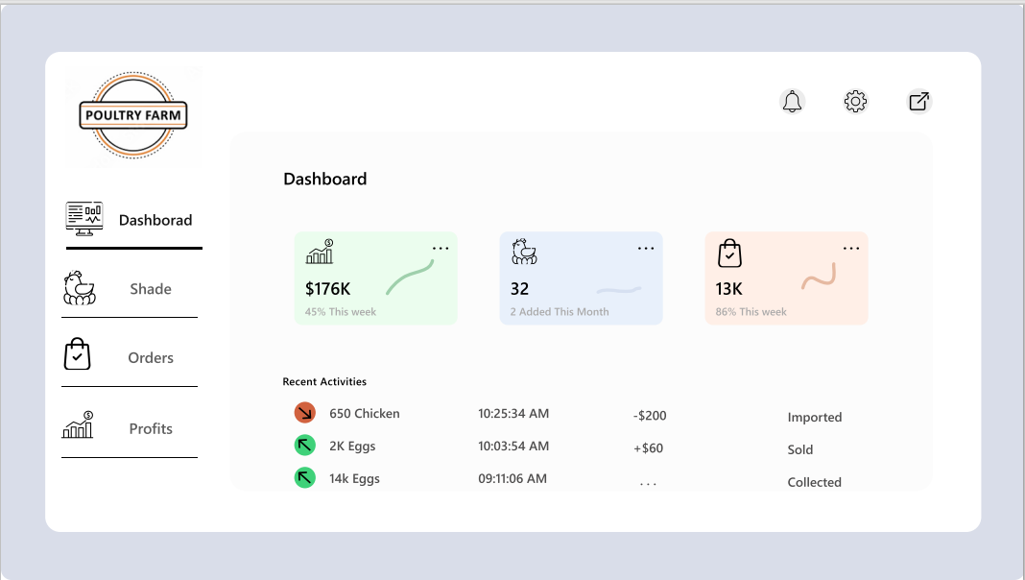

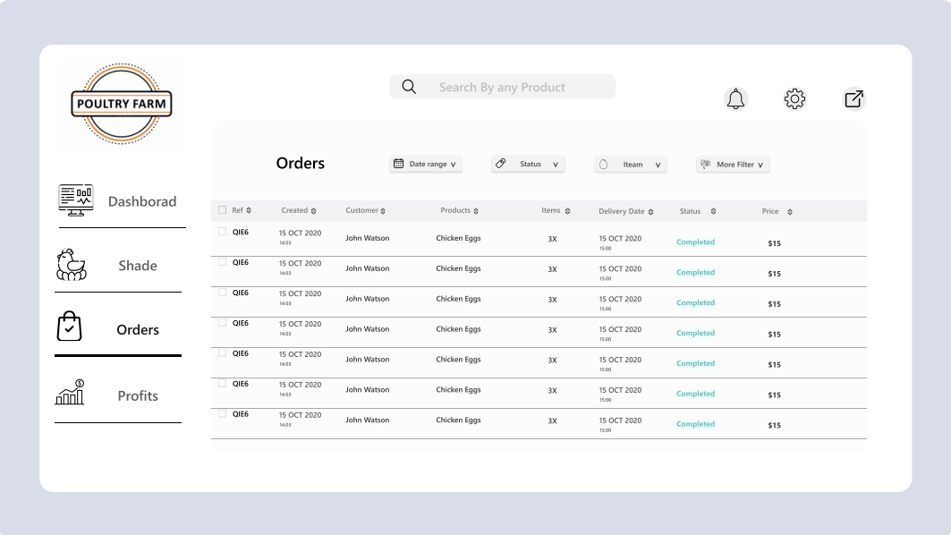

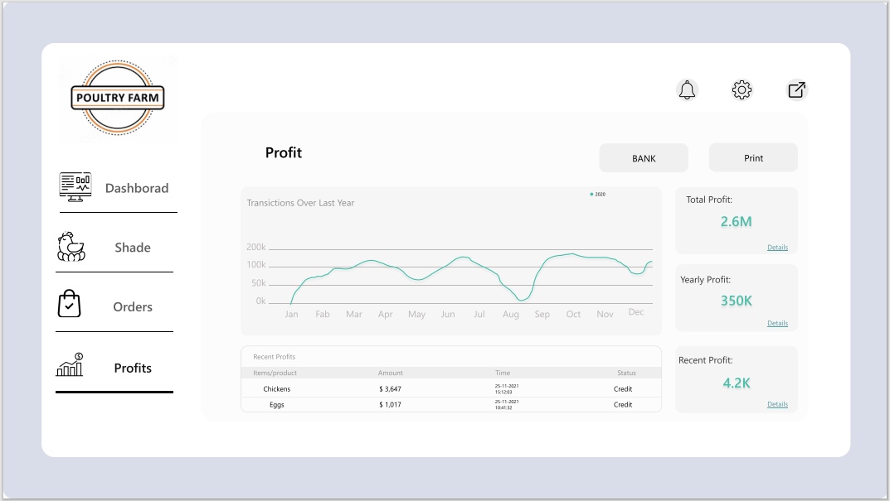

**6. Cost and Profit Analysis:**

PM = 2.4 * (3000/1000)1.05= 7.6065

DM = 2.5 *(7.6065)0.38 = 5.4049

ST = 7.6065/ 5.4049= 1.40733

Weeks = 6 * 4 = 24

|  |  |  |  |
| --- | --- | --- | --- |
|  | | | EVA |
| Task  1 | Planned Effort  4 | Actual Effort  5 | >BAC= 160 |
| 2 | 3.5 | 4 | >SPI= BCWP/BCWS = 40/66=0.6061 |
| 3 | 4.5 | 5 | >SV=BCWP-BCWS=40-66= -26 Person Day |
| 4 | 5 | 4 | >CPI=BCWP/ACWP=40/42=0.9524 |
| 5 | 3 | 4 | >CV=BCWP-ACWP=40-42= -2 Person day |
| 6 | 2.5 | 2 | > % schedule for completion = |
| 7 | 6 | 5 | BCWS/BAC=66/160=41.25% |
| 8 | 4 | 5 | > % complete = BCWP/BAC=40/160 = 25% |
| 9 | 3 | 3 |  |
| 10 | 4.5 | 5 |  |
| 11 | 5.5 | -- |  |
| 12 | 7 | -- |  |
| 13 | 6 | -- |  |
| 14 | 3.5 | -- |  |
| 15 | 4 | -- |  |

Given total task= 43 ; PM= 7.6065

Effort Estimated = 8*4*5= 160 person day.